09 September 2026
H2KNOW Programming Process
Overview of Process:
There are two major steps to install H2know:
- Provision the sensor
- Install sensor on pipe
Provisioning the sensor - or sensor programming - can be done as soon as you have the Budderfly Wi-Fi credentials for the store (the SSID and PW). This step requires a stable internet connection and can be done at the store but also at home or office.
Installing the sensor on the pipe is the second step. It is highly recommended to ensure the sensor is connected to WiFi before physically installing the sensor on a pipe.
Installation Requirements:
- Laptop or Mobile device
- Internet connection
- Network Name and Password
- Watermonitorapp.com login
Sensor Programming:
Begin by confirming that the H2KNOW sensor, its components, as well as a computer/mobile device, is present for programming purposes.
Use the provided cable to plug the H2KNOW sensor into a power source
  - A solid orange indicator should appear indicating the device requires a Wi-Fi connection
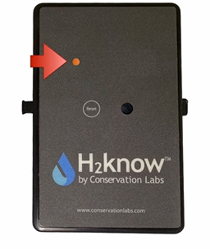
- Using your preferred web browser navigate to www.watermonitorapp.com and proceed to login using your username and password.

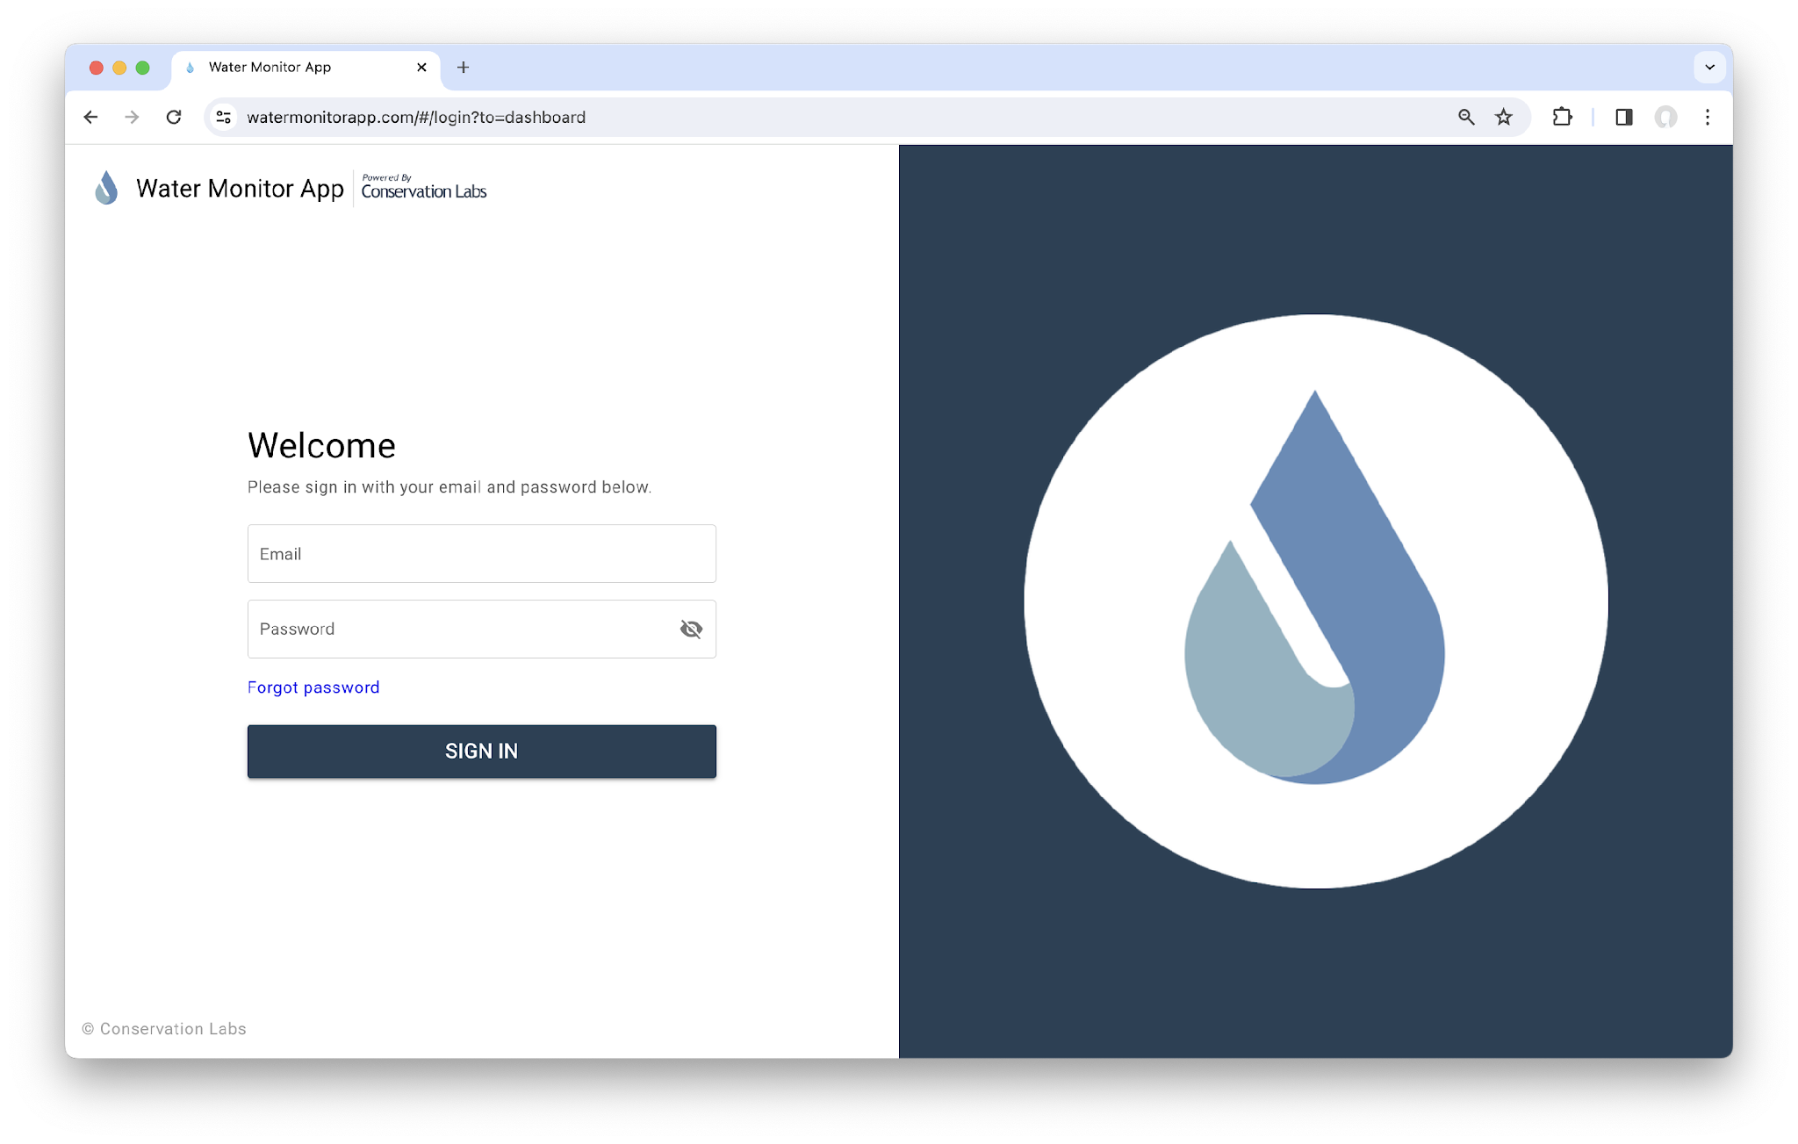
- Once logged in, the user will be met with the water monitor dashboard. Select “Deployment” to transition to the next page.
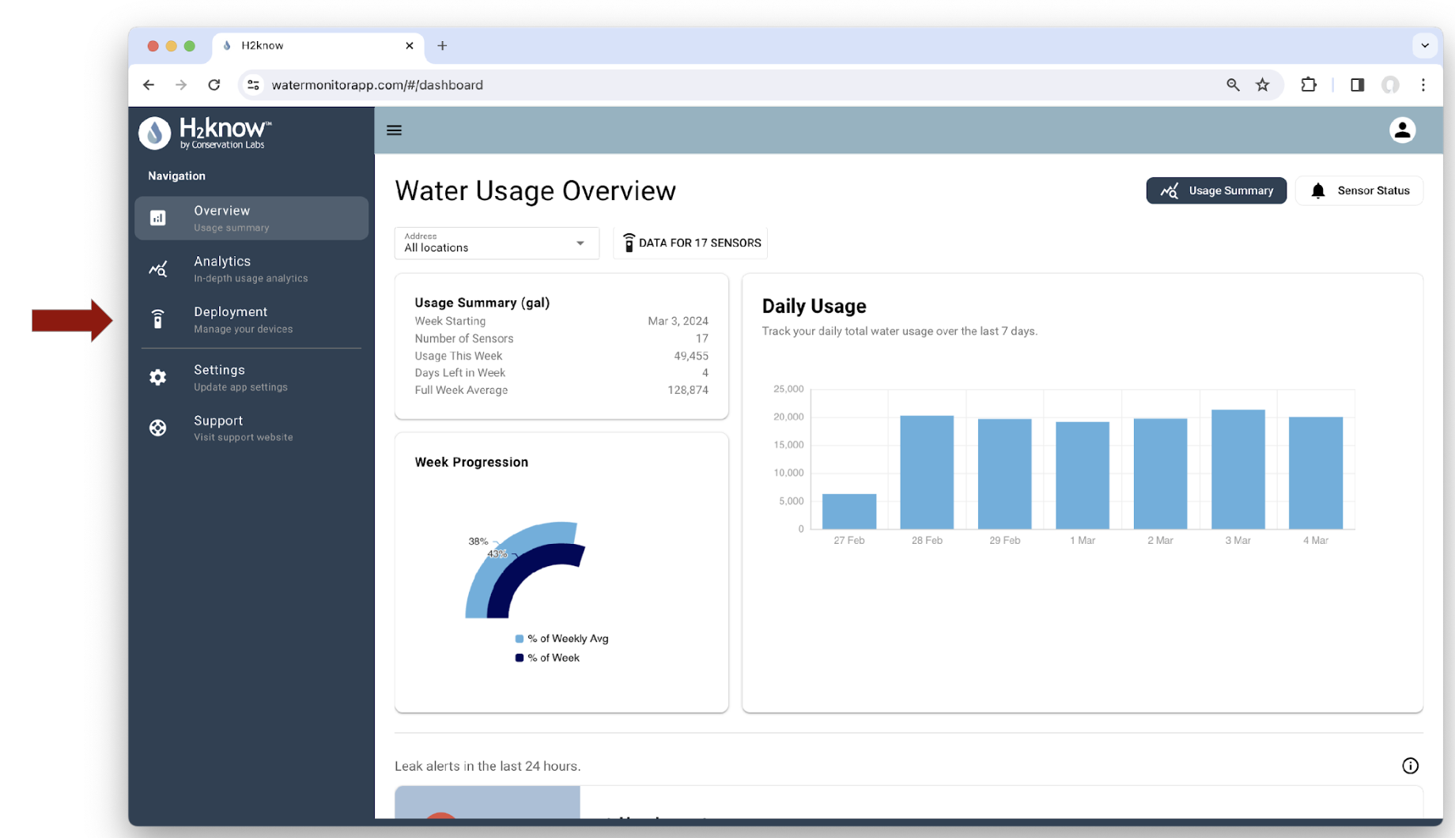

- Next, select the “Sensor Deployment” option located on the top.

- If the “Single Sensor Setup” option is not visible, select the icon located to the left of the water drop to expand the page.
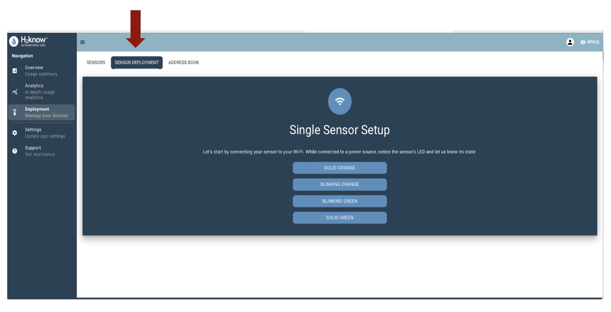

Programming the H2KNOW Sensor
The following steps are required to connect the sensor to Wi-Fi and confirm data transmission
- Check sensors LED status (LED can be located on the front of the sensor)
- Via your computer/mobile device select the status of the LED from the options provided (for new sensors, the LED should be Solid Orange).
- Access the computers/mobile devices Wi-Fi settings and search for available Wi-Fi networks. All sensors will have “Water Monitor” followed by a serial number.
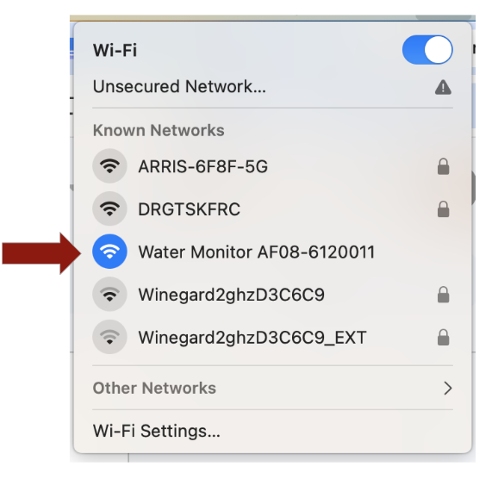
- Click on the “Continue” but only after you have connected to the sensor in your Wi-Fi settings.
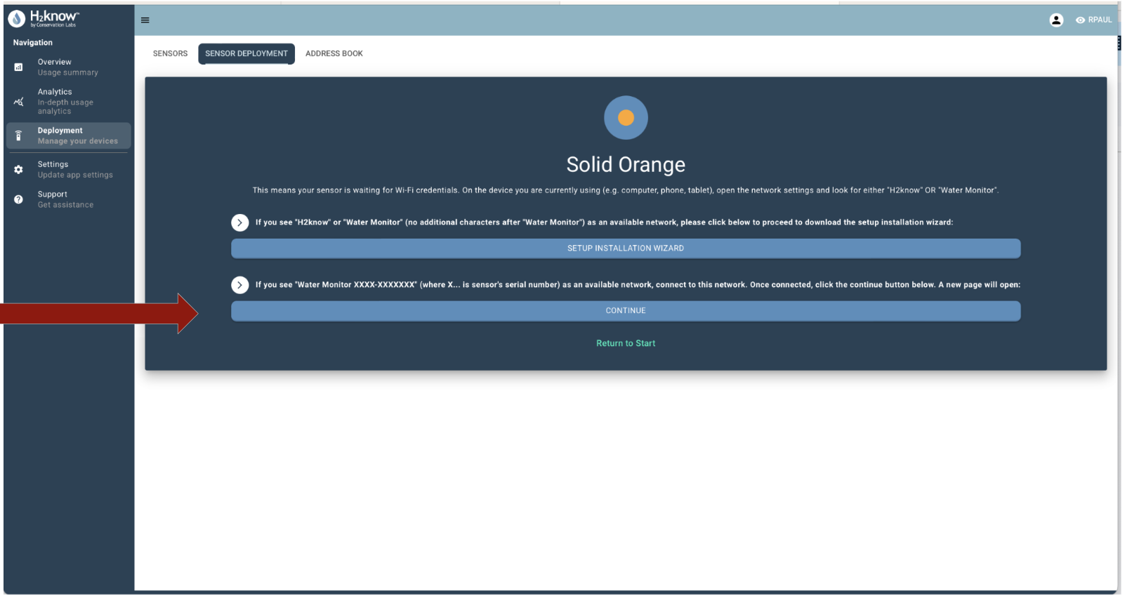

- A new page will populate prompting the user to enter the networks “SSID” and “Password”. Enter the network name and password for the store then select “Go” to connect.
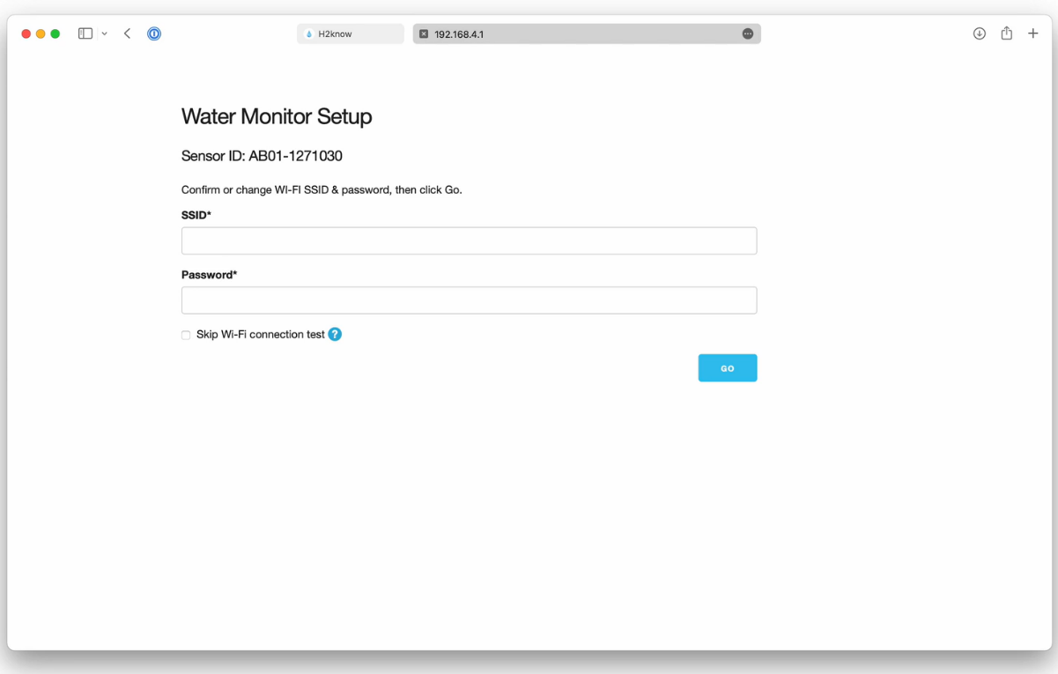
- A message will appear once the H2KNOW sensor is ready to transmit data over Wi-Fi. Note: your are likely in a new tab in your browser. You can close this tab and go back to watermonitorapp.
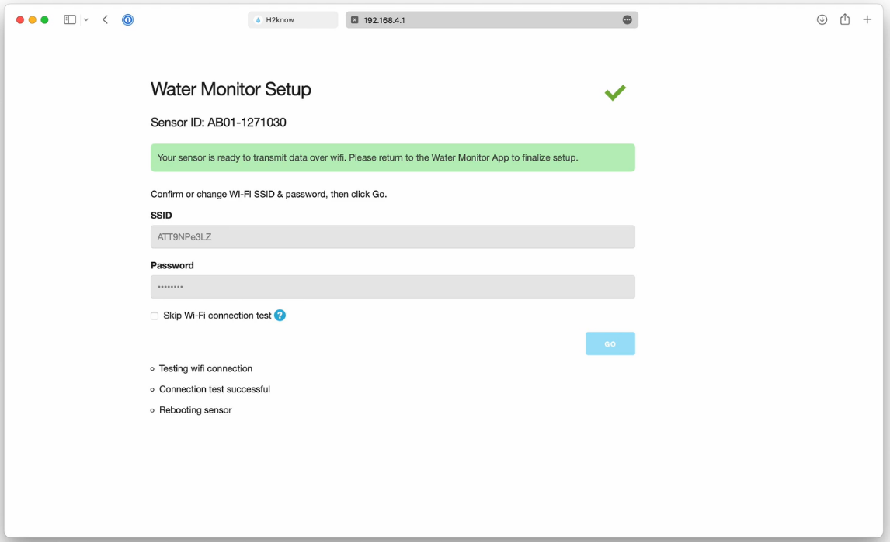
- Once you go back to watermonitorapp, the connection has been completed, select “Continue” to be brought back to the main screen.
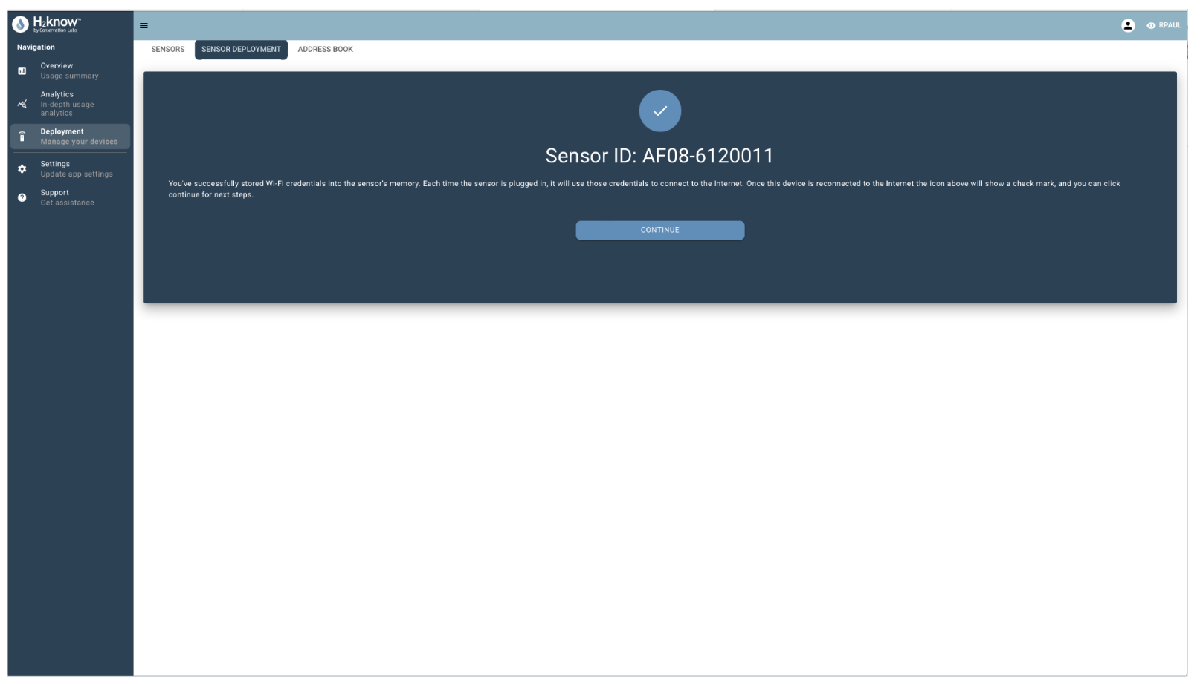
- After the sensor has been successfully programmed, you will be directed to the following page
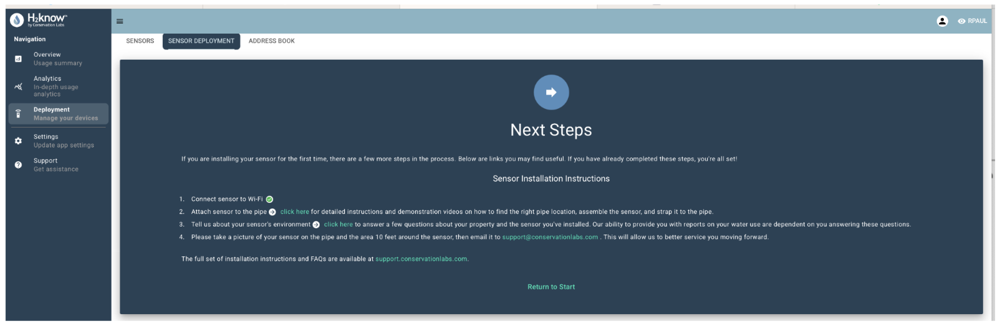

- The user will also receive the following email.
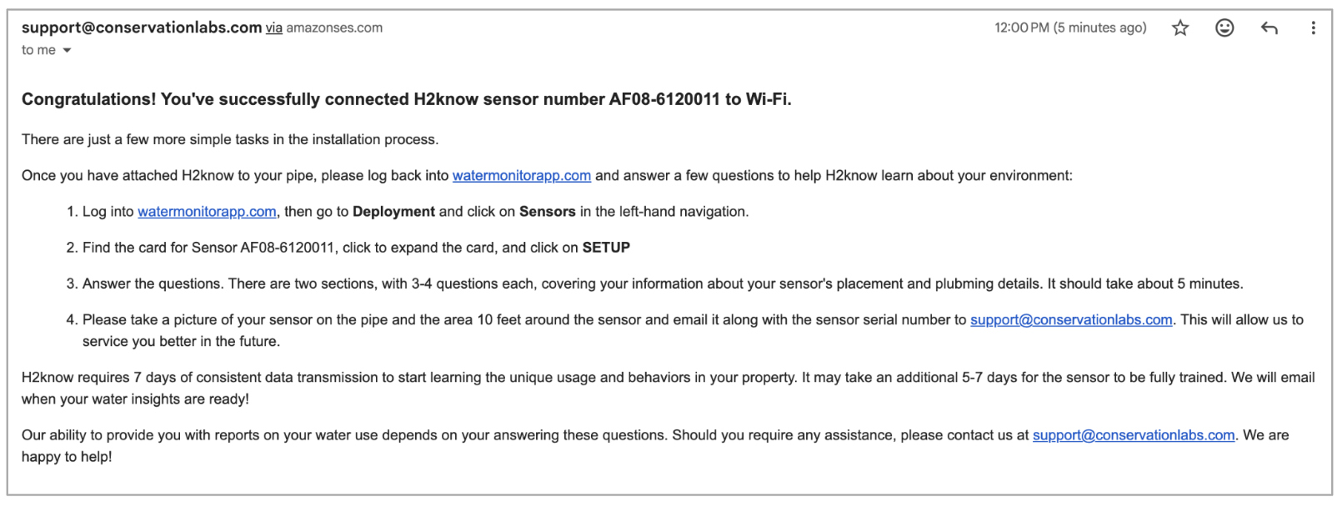
- At this point, if you have the relevant data, you can complete the installation questions in the application. Otherwise, you can transition to the installation process and take note of the environment to answer the questions. Note: if the questions are not answered, the sensor will not function properly.

Configuration Questions for the H2KNOW Sensor
The following steps are required to complete the configuration process.
- In the Deployment / Sensor section, choose the sensor you are installing.
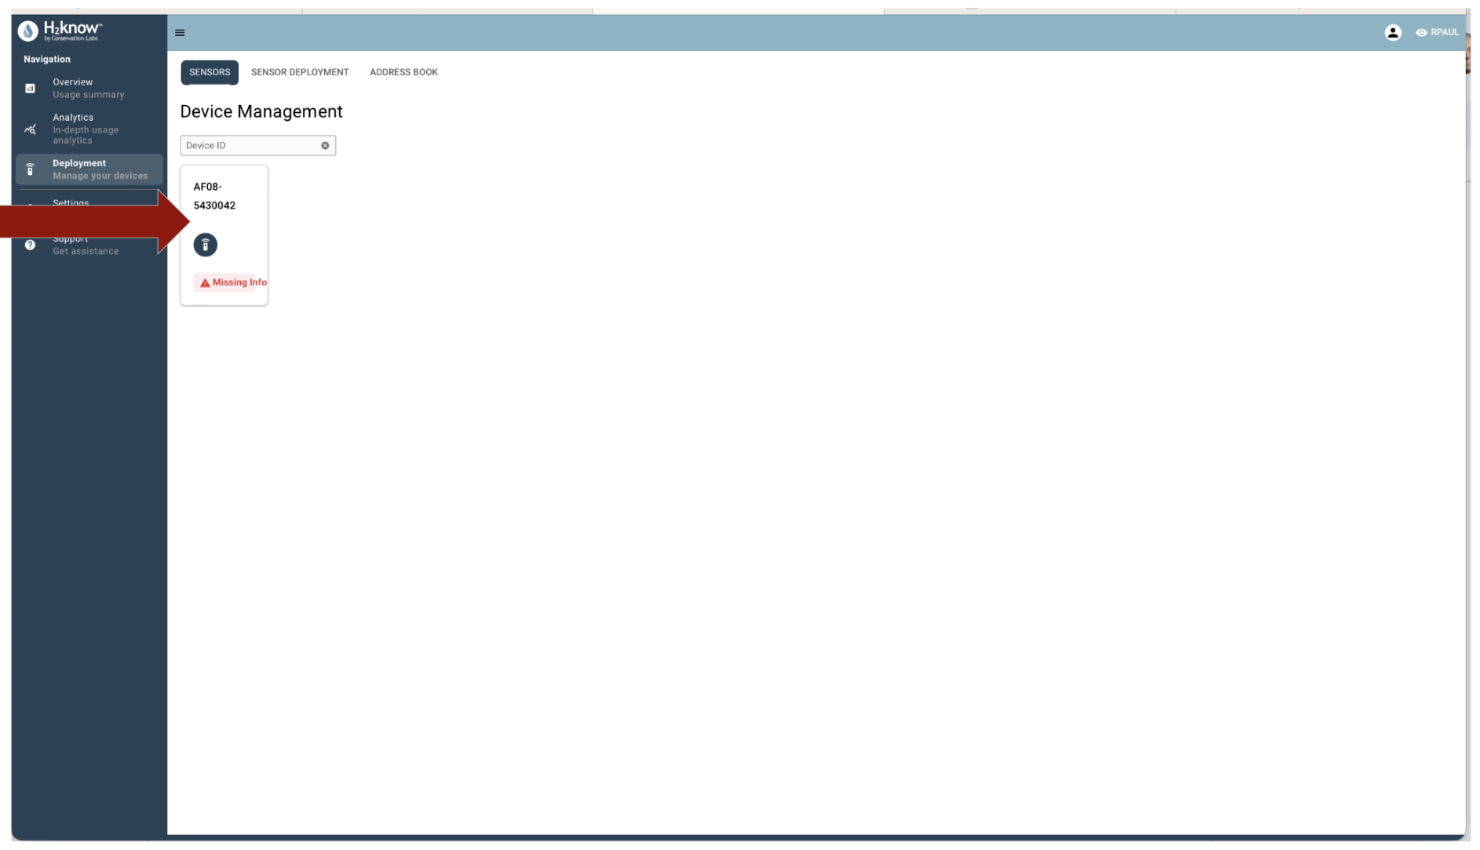

- The user will see a screen with three menus: Main, Environment, Plumbing (partial screen shown below). The Main menu will be pre-populated with the Name, Address, and Environment that was pre-assigned to the H2know serial number.
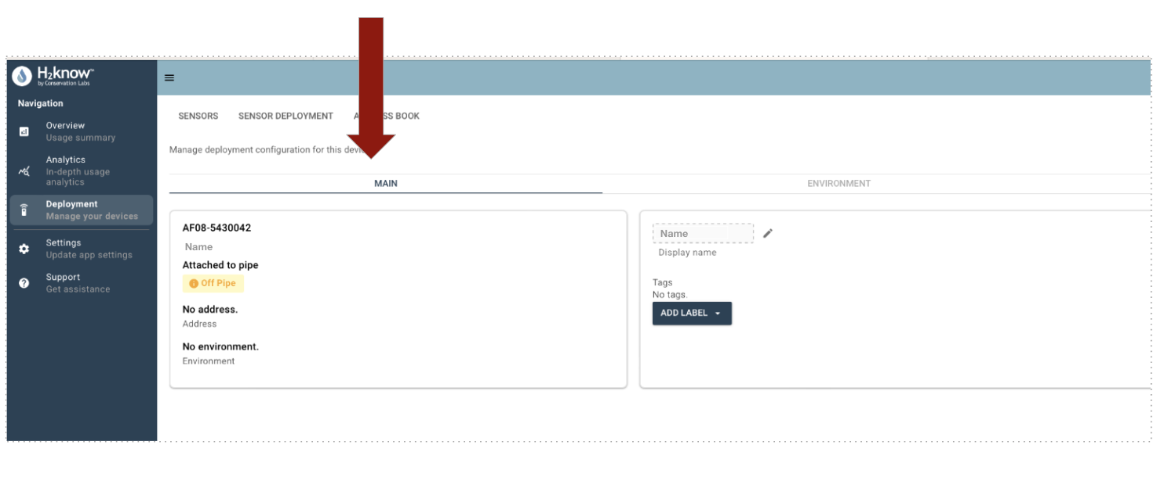
- If this Environment is incorrect, then go to the Environment section - and select a new environment (you should never create a new environment)
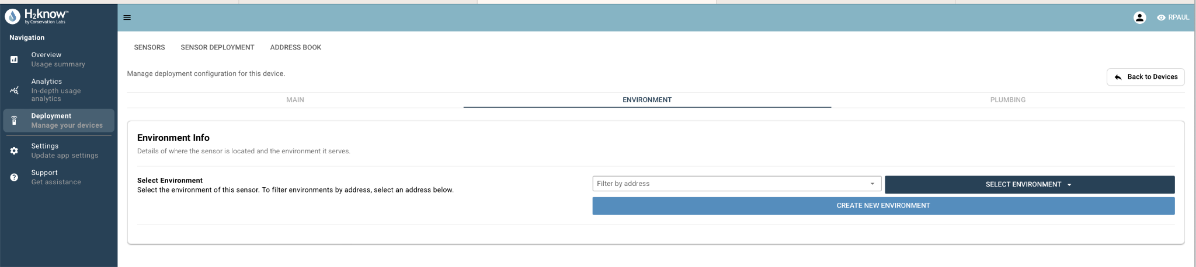

- Finally, navigate to the Plumbing section and answer the four questions about the plumbing environment.
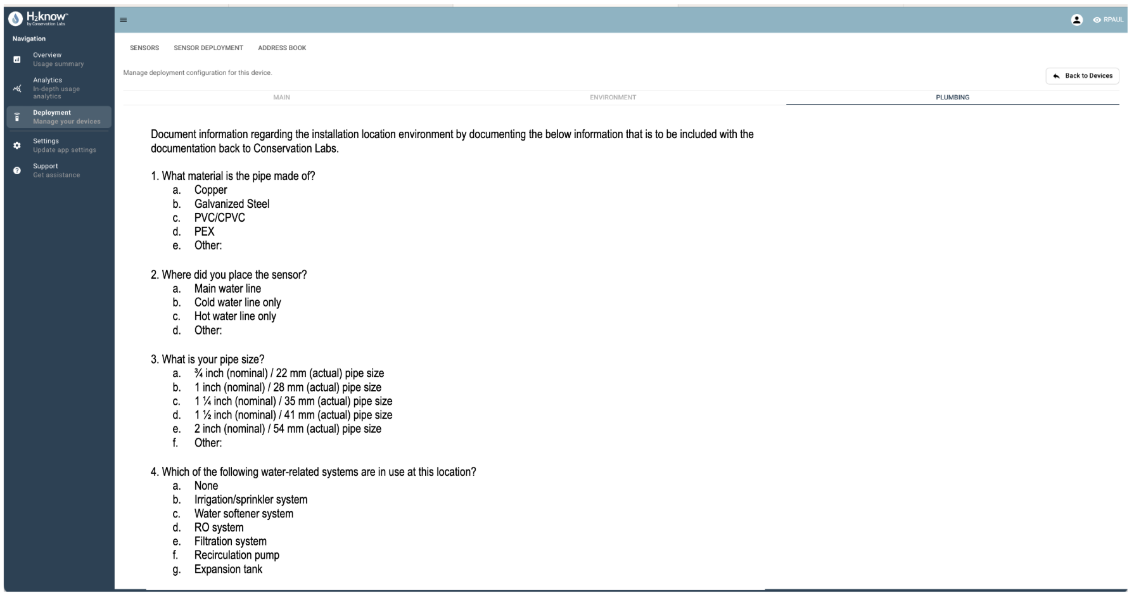

- Once all 4 questions have been answered accurately the configuration process will be complete.

Sensor Placement & Installation:
- Once the sensor has been connected to the network the installer can transition into the installation phase.
- The process begins by locating the section of pipe where the sensor will be installed
  - The sensor should be installed on a straight section of pipe after the water meter and before the hot and cold lines split off.
  - The location is ideally downstream of any backflow preventer or pressure reducing valve.

- After the installation site has been identified, the installer will begin assembling the sensor (Note: the sensor comes with three different pipe couplers. Select the coupler that fits the installation site best)

Label | Pipe Dimension
1 | 3/4”
2 | 1” - 1 ¼”
3 A/B | 1 ½” - 2”

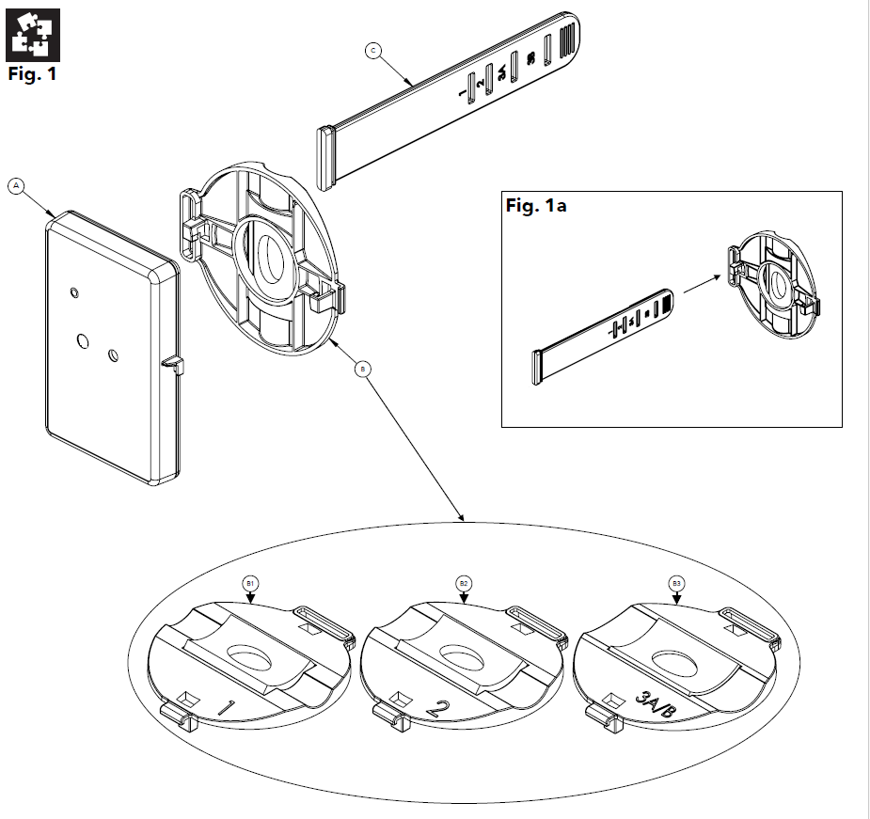

- Once assembled the installer will now proceed with securing the sensor to the pipe using the provided strap. (For a full demonstration on how to assemble the sensor, or the installation process, select the hyperlink provided below)

  - H2KNOW Installation Process: Click Here
- Connect USB cable to the sensor and adapter and plug it into the nearest outlet.

Installation Considerations:
- Install inside only. The product is not intended for outdoor use.
- Do not install in an area that will directly expose the device to water or other liquids.
- Do not install in an environment that exceeds the operation temperature of the device (-20°C to 60°C / -4°F to 140°F).

